
Denis Chaussée
Institut des Sciences de l’Ingénieur de Montpellier


Water sciences department

June the 16th 2003– September the 7th 2003

Svanhovd environmental centre



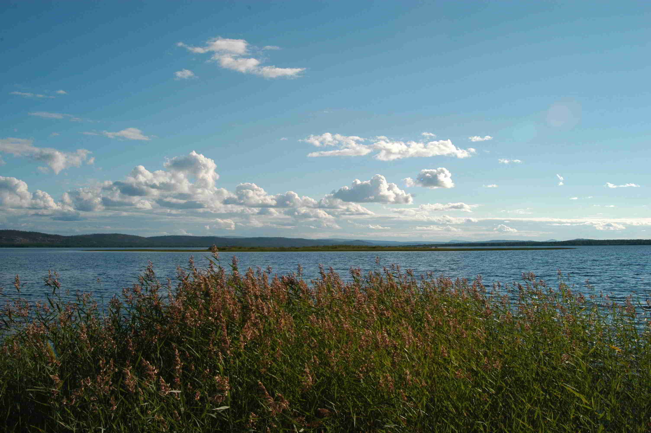
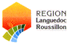
With the financial support of:

Subject:

- The TRANSCAT project and the Water Framework Directive

- Watershed modelling

- Stakeholders contact
Interconsult tutor : Arve Misund

ISIM tutor : Luc Neppel
CONTENTS
Contacts with stakeholders: 3
Finnmark County: 3
Sør Varanger municipality: 3
Pechenga municipality: 3
Problems faced: 4
The WFD, a tool for the water management in the Pasvik region 5
The Water Framework Directive (WFD): the problems faced by his implementation 5
River Basin District 5
Water bodies 5
Identification and designation of Heavily Modified Water Bodies (HMWB) 6
Establishment of ecological status and reference conditions. 7
Identification of body at risk 9
Monitoring programmes 9
Environmental objectives and programme of measures. 9
The objectives 10
Watershed modelling: CatchmentSIM 12
The Digital Elevation Model (DEM) : 12
DEM importation: 13
Flats and pits treatment: 15
Computed hydrological network: 16
Hydrological modelling : 16
Importation of the real stream network: 17
Conceivable solution: 17
Conclusion and comments: 18
Experiences and general conclusion: 18
Acknowledgements 18
ANNEX I 19
ANNEX II 23

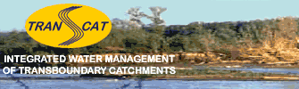

Contacts with stakeholders:

This aspect was completely new in my training. Even if sometimes I was lost, this experience was formative.
The main feeling I had along this meetings is that people have difficulties to imagine what can the DSS offer them, how it can be helpful.

Finnmark County:
Hence Bente Christiansen told me that the project seems interesting but in her opinion this kind of software is a future tool, still in the research domain. She does not have a real conception of what can the DSS offer her department.
Then it could be useful to create a small demo, even on an unreal case, to make them conceive a concrete conception of the DSS.
The second point, which emerged from our interview, is that we should be careful not to teach local decisions makers their job. Bente Christiansen experimented such case where the arguments and advice the project put forward was not relevant and did not provide new vision of the problems. That is Bente Christiansen’s apprehension. Thus, we should keep on this direction to ask them what they expected from such tool; but then we come round to the first point

The county must be an important interlocutor as for the economic angle. Indeed as they may be the authority in charge of the implementation of the WFD, they will have to complete an economic characterisation of the water uses by 2004 in order to allow a discussion on the cost effectiveness of the measures to be taken. Then the collaboration with this department can be favourable to both. They can inform us about their needs and problems they face, and the outcomes of the DSS can help them in their analysis.

Sør Varanger municipality:
I feel that among the people I met, Trygve Sarajarvy is the one who has the best conception of this kind of tool. I did not talk a lot with him and he seems very busy, but he may have constructive comments.
From the short interview we had with him emerges that concrete results are the main purpose to work toward an end.

Pechenga municipality:
We met in June Vladimir Chizov: the main goals of the interview were to present the Iron Curtain and Transcat projects and assess if the municipality would be able to collaborate.
His main queries concerned the future use of the DSS and the choice of the pilot site:
How the DSS can be used, what are the advantages?
Who chose the site and which were the criteria?
Then concerning the Transcat project he asked us if we will have to sample on the Russian side, which partners do we have.
Hence, he listened to us carefully but he did not provide us any answer as for collaboration; he had to ask his superior. On the other hand, he would prefer contacting Sør Varanger municipality before getting involved in the project.
Then he required a thesis, in Russian, summarizing the aspects of the project.
He finally informed us about his concern with regard to post project: he experimented several projects where the scientist disappeared after the end of their work, without any feedback to the municipality.

The European nature of the project may confer it a “bureaucratic” connotation, launched by the higher reaches of Brussels. I didn’t feel it, talking with people, but I think it is a possible feeling. So we should be careful to keep a concrete direction.

I think, a meeting with local stakeholders (and with the Russians would be perfect), so that they could share their point of view and requirements about the project; constructive ideas could emerge. Mr Chizov touched on this question of a meeting with other stakeholders.

Problems faced:

On one hand, the communication with Pechenga municipal is delicate. The pyramidal decision system does not allow decision in a lower level.
Through the interview with Mr Chizov and discussions I had with Paul Eric Aspholm about the project, Vladimir Chizov seems to be open to collaboration. Nevertheless, the mayor, Andrey Ivanov is more recalcitrant and seems to slow the communication. They should have come on August the 18th for the anniversary of Svanhovd and Pasvik nature reserve, but they didn’t show up.

Hydromet is also an interesting potential stakeholder, which holds many consistent data. But the communication is very complex. Indeed it is an official state service and wants to collaborate with another official institution. Hence the collaboration may be difficult. However, Finnmark County is planning to buy data from Hydromet as part of a monitoring programme.

On the other hand the main problem is the lack of consistent data about the biological, chemical status of the river. Few surveys were carried out and without any normalization, each one studying different sites and different indicators. Hence there is no steady follow up of the water quality, what makes difficult collecting data. Three years chronicle are very seldom and concerns few indicators.
However, Finnmark county and Finland will launch a 4 years monitoring programme this autumn and the county environmental department can provide us the first results.

Thus, the work regarding the indicators to be used to characterize the ecosystem is delicate seeing the quality of the data. Then a list of indicator can be established in relation to the available data (see annex I).

The WFD, a tool for the water management in the Pasvik region

The transboundary catchment of the Pasvik River is shared between Finland, Norway and Russia Federation. All three countries have interest in cooperating with each other. That is why the Water Framework Directive could become a tool for water management of the Pasvik basin. Moreover, Finland as a EU-member must implement this directive and the WFD is also legislative in Norway.

The Water Framework Directive (WFD): the problems faced by his implementation

The Water Framework Directive establishes a framework for the protection of all waters which:
Prevents of further deterioration of, enhances the status of all waters resources
Bases the management on river basins and promotes sustainable water use.
Aims at enhancing protection and improvement of the aquatic environment through specific measures for the progressive reduction of discharges.
Ensures the progressive reduction of pollution of groundwater.
Contributes to mitigating the effects of floods and droughts

The implementation of this framework requires several actions to be taken in a definite timetable:

Identify and assign river basins to individual River Basin Districts by 2003.
Characterize river basins in term of pressures, impacts and economics of water uses by 2004.
Identify in each river basin the different water bodies.
Define for each water body a good ecological status and the references conditions by 2006.
To make operational the monitoring networks by 2006.
To identify, by 2009, a programme of measures for achieving the WFD objectives, based on the monitoring programme.
Produce a River Basin Management Plan for each River Basin District by 2009.
Achieve the second river basin characterization by 2013 thanks to the monitoring programme.
Implement the programmes of measures and achieve the objectives by 2015.

River Basin District
The most efficient model for a single system of water management is management by river basin: the geographical and hydrological unit, made up of one or more neighbouring river basins together with their associated ground waters and coastal waters. In border areas between member states and non-member states an international River Basin District should be established.

Problem:
Pasvik River’s basin lies on Russia where the WFD are not legislative

Water bodies

A water body is a consistent unit at which the directive will be implemented. It must be a discrete and significant element. Technically, a water body is a contiguous unit made up of one water category (river, lake, channel). However, each water body must be a regular unit, with continuous hydromorphological and geographical features. For instance, the confluence between two rivers could demarcate a boundary to a water body. Or a lake, composed by two clearly distinct ecological zones can be divided in 2 water bodies.

Problem:
Pasvik River is characterized by a succession of wide and narrower zones. Hence the boundaries between the lakes and the river zones are vague.

Once the identification made, the WFD proposes two systems (A and B) to define the type of each lake and river. System A is based on 4 abiotic characteristics (altitude, mean depth, surface area and geology). System B includes these 4 variables as "obligatory factors", and a list of additional abiotic characteristics as "facultative factors".
One of the system A’s characteristics is the differentiation into ecoregions (Annex II) whereas the system B proposes a differentiation based on the geographical coordinates.

Norway has chosen the system B to define the type of its water bodies but the typology systems are still debated at European level (Assigning Water Body types an analysis of the REFCOND questionnaire results. Wouter van de Bund. European Commission, Joint Research Centre. Institute for Environment and Sustainability).
Indeed, one of the problems raised is that the typology depends on the purposes of the characterization. On the one hand the intercalibration between all the Europeans Water Bodies requires a simple and transparent system applicable all over the Europe. On the other hand, to establish reference conditions and environmental objectives, the system must be flexible and describe as accurate as possible the status of the body: therefore it may require different typology with different quality elements for each type of water body.

Problem:
The system chosen in the TRANSCAT project will have to allow a European network but also an optimal characterization of the bodies to create the DSS.

Identification and designation of Heavily Modified Water Bodies (HMWB)

HMWB are bodies of water, which as a result of physical alterations by human activity are substantially changed in character and cannot, therefore meet the “good ecological status”. In this context:
Physical alterations means changes due to the hydromorphological characteristics of a water body.
A water body that is substantially changed in character is one that has been subject to major long-term changes in its hydromorphology.
To be designated as a HMWB, the specified uses of the water body (navigation, hydropower, water supply, flood defence) must be significantly affected by the restoration measures. The second test requires that there are no significantly better environmental options for delivering the special use that are technically feasible and cost effective. A water body can also be designated as Heavily Modified when the removal of a modification would lead to the destruction of valuable environmental features.

Hence, instead of “good ecological status”, the environmental objective for HMWB is “good ecological potential” (GEP). GEP means slight changes in the value of the relevant biological quality elements at “maximum ecological potential” (MEP). The MEP represent the maximum ecological quality that could be achieved for a HMWB once all mitigation measures that do not have significant adverse effects on its specified use or on the wider environment, have been applied.

Thus, several water bodies of the Pasvik River might be identified as HMWB seeing the fact that the height dams represent changes in the hydromorphological characteristics and also important economic and social uses. But the guidance document stipulates that only physical alterations in the morphology and hydrology of the river can lead to the designation of HMWB.

Therefore, Pechenganikel plant cannot lead to the designation of HMWB for the water body of Kuestsyarvi Lake.

Establishment of ecological status and reference conditions.

In order to define the objectives to be met, the ecological status of each water body must be assessed. A preliminary status can be establish thanks to a pressure and impact analyses (see Annex 1) and then allows a screening of the potential reference conditions sites where the anthropic pressure is nil.
Indeed according to the WFD reference conditions need to be established for water body types. Then the ecological quality ratio (EQR) could be calculated for each water body types to establish class boundaries between good and moderate ecological status. Finally these quality scales for each type of body can be harmonized by a European intercalibration. This first draft characterisation (ecological status, potential reference sites and potential intercalibration sites) should be completed in December 2003. As this exercise will be completed before the monitoring programmes are fully operational, pressure criteria for selection of sites will have to be used together with existing survey data on ecological status.

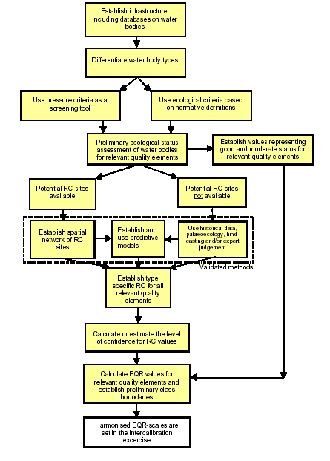
Figure 1: Flow-chart of the suggested step-by-step approach for establishing reference conditions and
boundaries between high, good and moderate ecological status classes (RC=reference conditions,
EQR=Ecological Quality Ratio).

However, the same problem is raised, the relevant elements used to assess the ecological status and the reference conditions depend on the purpose: intercalibration (data base) or accurate characterization.

The WFD do not provide a specific method as for the reference conditions, the main options for establishing reference conditions are:
Spatially based reference conditions using data from monitoring sites where the pressure is absent.
Reference conditions based on predictive modelling calibrated on reference sites from similar regions.
Temporally based references conditions using either historical data or paleoreconstruction or both.
A combination of the above approaches
Expert judgment

Hence the “good status” represents a slight deviation from the reference conditions.

Identification of body at risk

A body at risk is a water body where human pressure is a danger of not complying with “good status”. A preliminary identification will be made thanks to the pressures impacts analysis and confirmed by a monitoring programme. These analyses should be completed at the latest in December 2004. Then a particular attention will be devoted to these water bodies by a monitoring programme.

Monitoring programmes

To definitively assess the ecological status of water bodies and to monitor the evolution of the body at risk, a monitoring programme should be establish before 2006.

Problem:
The main part of the Russian Pasvik shores and the Russian part of the catchment is a military zone. Therefore accesses are strictly regulated which make sampling difficult even for Russian scientists. For instance, special authorizations are required to take the road between Nikel and Rajakoski.

Environmental objectives and programme of measures.

Seeing the reference conditions and the ecological status of each water body, environmental objectives will be defined as well as the requisite measure.

Nevertheless the costs of the programmes must take the particular economic situation of the Pechenga municipality into account. Indeed the Pechenganikel activity represents 92% of the Pechenga district economy. Hence the Pechenganikel has a very unstable economy, based on the world market prices on nickel and non-ferrous metals. In addition the district is now supposed to take over the building complexes and social infrastructure earlier supported by the mining company and the military.
The environmental problems are not the first priority in the Pechenga district, thus the environmental objectives must take the standard of living gap and the economic gap between Pechenga district and Norway or Finland into account.

The objectives

Pasvik River’s basin lies on a non-EU member state where the WFD are not legislative.

The implementation of the WFD is a volunteer action for a non-member state. However, EU WFD and the Russian Water Code are based on a River Basin approach and both aimed to protect al categories of water (surface waters, coastal waters, groundwater and transitional waters). In Russian federation the responsible for water management is the Ministry of Natural Resources (MNR). At the territorial level it is presented by Committees of Natural Resources (CNR of Murmansk region). In the field of transboundary water management, three commissions work in the region:
A Norwegian-Finnish-Russian commission dealing with hydropower production.
A Norwegian-Finnish commission on transboundary waters in cooperation with representatives of Murmansk CNR.
A Joint Finnish-Russian on Transboundary Water Systems.
According to the Mantra East report (Review of existing structures, models and practices for transboundary water management) these commissions do not cooperate closely and the local municipalities are not involved in the decisions.

Hence the main objective of the project should be to involve the local municipalities (Pechenga district and Sør Varanger municipality) as well as the decision makers dealing with water management on both sides (Murmansk CNR and Finnmark county authority).

Pasvik River is characterized by a succession of wide and narrower zones. Hence the boundaries between the lakes and the river zones are vague.

The problem should be solved by the expert in charge of the implementation of the WFD.

The system chosen in the TRANSCAT project will have to allow a European network but also an optimal characterization of the bodies to create the DSS.

Different typology may be needed for the purpose of establishing accurate reference conditions, characterization and intercalibration. Otherwise, a common system between the five experimental sites may be created, reaching a compromise between accuracy and universality. Indeed even among the 5 experimental sites the number of ecosystem and therefore of water body type is huge, and each one is different from the other, what requires a number of different indicators.

Therefore, Pechenganikel plant cannot lead to the designation of HMWB for the water body of Kuestsyarvi Lake.

Considering that the lake may not be able to reach a “good ecological status”, it could be designated as a water body at risk of not complying good ecological status. Accordingly, the water body should be strictly monitored to assess the evolution of the ecosystem in order to implement the most adapted measures.

The main part of the Russian Pasvik shores and the Russian part of the catchment is a military zone. Therefore accesses are strictly regulated which make sampling difficult even for Russian scientists. For instance, special authorizations are required to take the road between Nikel and Rajakoski.

The project does not foresee monitoring programmes. However, Svanhovd miljøsenter had some authorizations to work and sample on the Russian side of the river. Hence the contact should be kept up thanks to Svanhovd miljøsenter.

The costs of the programmes must take the particular economic situation of the Pechenga municipality into account. Indeed the Pechenganikel activity represents 92% of the Pechenga district economy. Hence GMK Pechenganikel has a very unstable economy, based on the world market prices on nickel and non-ferrous metals. In addition the district is now supposed to take over the building complexes and social infrastructure earlier supported by the mining company and the military.
The environmental problems are not the first priority in the Pechenga district, thus the environmental objectives must take the standard of living gap and the economic gap between Pechenga district and Norway or Finland into account.

A component of the WFD, as well as of the TRANSCAT project, is an economic analysis of water use. This is to enable a rational discussion on the cost effectiveness of the various possible measures. That is why the project should work in harmony with the competent authorities that are in charge of the implementation of the directive and which will complete this analysis.

Watershed modelling: CatchmentSIM

The initial objective was the creation of a hydrological model of Pasvik catchment. The software I used for the hydrological treatment of the DEM was CatchmentSIM, a shareware developed by the university of Wollongong (Australia).

The Digital Elevation Model (DEM):

The DEM to be used, was provided by Zoya Makarova (INEP). The resolution is 100m but it does not cover the whole catchment. However seeing the size of the catchment and the performance of the computer to be used, we decided to modelize a subcatchment of the Pasvik river : Kuetsyarvi lake subcatchment.
In addition the DEM does not contain the lakes’ elevation, consequently the file is riddled with holes.
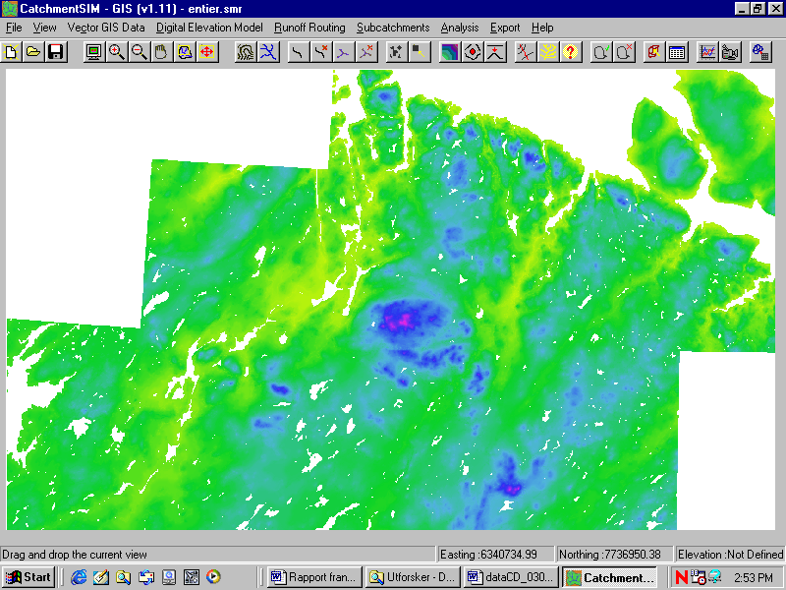
Barents sea
Inari lake

North

Norway

Russia

Finland
Figure 2: The Digital Elevation Model.

Hence we can see on the DEM that there are no data as for the lakes on the Pasvik River.

DEM importation:

We will focus on the importation of existing DEM, development of DEM by rasterisation and interpolation of contour data are explained in the CatchmentSIM tutorial.

Once the DEM to be imported is selected and the importation form displayed, the user can select a zone to be imported by entering coordinates or selecting the zone manually.

Potential problem:
If the message “one of the coordinates” is not a valid floating-point value is displayed, you should change the decimal separator in the regional settings.

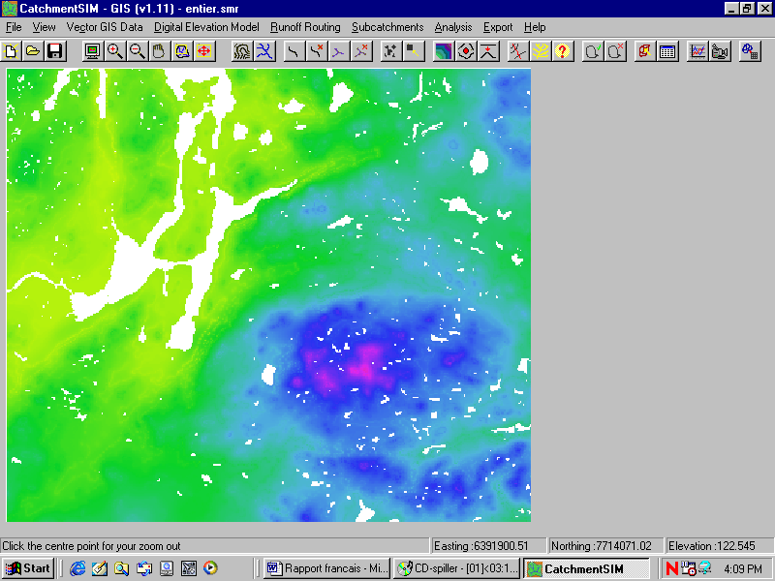
Nikel
Svanhovd miljøsenter
Figure 3: Nikel area.

The first task was the assigning of an elevation to lake pixels. Otherwise the automatic catchment delineation will lead to an incomplete basin with holes corresponding to the lakes. Indeed, all the water drained by the lakes « disappears » and does not flow until the mouse of the catchment (see annex I).
The only tool available in CatchmentSIM is the DEM interpolation tool, which is normally used to develop a DEM from a vector file containing elevation lines. Thanks to this tool the software interpolates elevations regard to the elevation and distance of the neighbouring pixels.
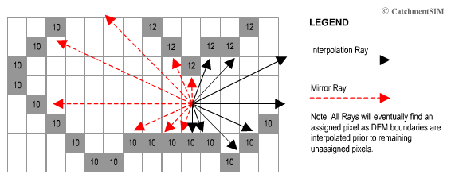

I also tough of filling in the file manually but having regard to the size of the DEM and the number of lakes, this work was huge.
The interpolation completed, elevations were assigned to the lakes but these ones was not flat due to the relief of the shores. Consequently, the run off was significantly different from the real one.

Flats and pits treatment:

In case of flat regions or in the confluences the software may not find altitude differences between pixels or downslope pixels in hollow zones.
The treatment of flats and pits is important especially round about outlet zones. Indeed the flow accumulation in the pixels around the outlet is high, thus if a stream reaches a flats or a pits the flow will be “lost”.
In order to treat these zones, CatchmentSIM provides two tools:
- Filling algorithm: this tool increases the elevation of pit pixels until the closest and lowest pixel’s elevation. As for flat areas, it increases the elevation of some pixels to have a slight slope.
- Priority First Search (PFS) breaching algorithm: this algorithm search for each pit or flat pixel, a pixel with a lower elevation. Then it establishes the optimum flow path between these pixels and decrease the elevation of pixels on the path, in order to create a run off.
According to me, the PFS algorithm is well adapted to the wide flat zones. Indeed, in such zones, it creates a trench ramification like flow networks draining wetlands.

However, the MNT contains few flat zones but many pits probably corresponding to small lakes (one pixel size). Hence, the first algorithm is more adapted. In addition, the PFS algorithm can create deep trenches in case of abnormally low pixels compared to his neighbours (error in the DEM, low quality). If this pixel is isolated and remote from a lower zone, the algorithm will create a deep canyon.

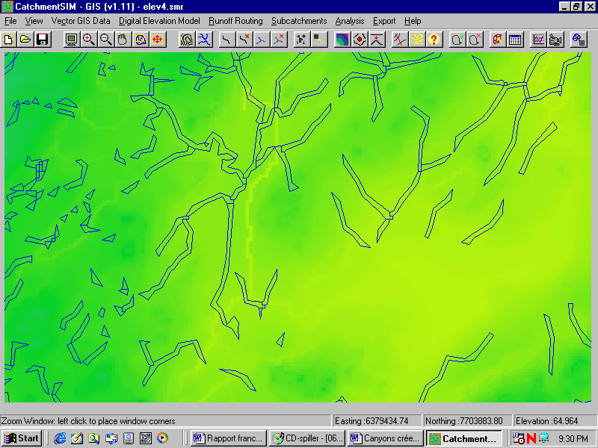
Trench created by the PFS algorithm

Pixel treated
Figure 4: example of pit treatment by the PFS algorithm.

We can see on the figure 4 that the algorithm created a trench from a pit pixel, creating a drainage axe. However this axe is different from the real hydrological network (blue). In this case the trench is 20 meters deep!
The PFS algorithm must be used carefully.

Computed hydrological network:

Before getting the real stream layer, I worked with the network which was computed by the software. In order to find an outlet for the catchment, I launched the tool: “DEM wide Flow Processing” which computes flow directions and then flow accumulation for each pixel. Thus the potential streams are displayed, and the outlet can be chosen. Then “DEM wide Flow processing” must be launch again to delimitate the catchment. In Nikel area the result was acceptable.

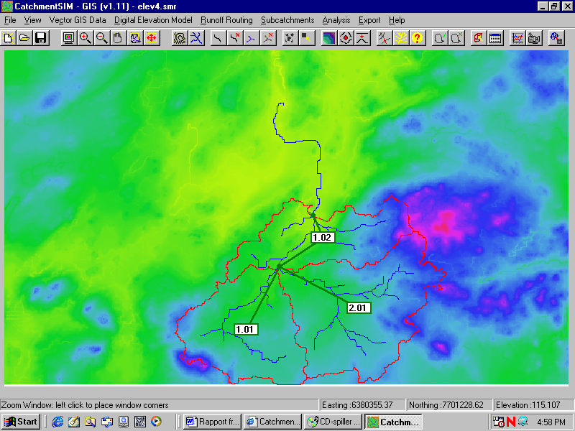
Figure 5 : real flow direction.

However, because of the lake interpolation, a stream was created in the Kuetsjarvi and Svanvatn lakes. This stream differs significantly from the real flow direction.

Hydrological modelling:

CatchmentSIM is coupled with different hydrological models: 3 Australian, and 1 American. As I don’t know the specifications of the Australian models I chose HEC-HMS that I studied a bit.
Thanks to a macro, it is possible to export the files necessary to create a HEC-HMS project for the modelling.
However, HEC-HMS is not adapted to the Pasvik region. Indeed, the ground is frozen for 8 month, preventing any surface or sub-surface flows. But the most problematic is that a complex process that CatchmentSIM cannot modelize manages the snowmelt. A year scale modelling cannot be done thanks to HEC-HMS. The other models do not include a snowmelt component.

Finally, the importation of the project in HEC-HMS was possible but the use of the tools (zoom, source addition…) made the software crash. I didn’t managed to find a solution even with CatchmentSIM’s developer and the questions I sent on HEC forums had no answers.

Importation of the real stream network:

Thanks to George Lev who made several conversions and provided me the shape file containing the real streams, I could import the stream layer over the DEM in order to force the flow to follow the real direction. But the file does not contain the Pasvik river because it is a succession of lake that cannot be represented by a vector.
Then in order to work only on Nikel area, I tried to window the layer. But CatchmentSIM provides a windowing tool (before importation) only to be used with DEMs. Importing a vector layer wider than the DEM is possible but the rasterisation of the network over the DEM made the software crash. Hence I imported the layer over the whole DEM and used the other windowing tool which enables the user to cut DEM thanks to a mobile window. Nevertheless the use of this tool had the same ending: a fatal error.

So I worked on the whole DEM to verify that the error came from the fact that the vector layer and the DEM had different boundaries. But the file to be treated is big so I had to launch time-consuming processes (interpolation, flats and pits removal) during the night.

Then I used the tool “interpolate stream over existing DEM). This algorithm controls that the elevation decreases on the DEM along the imported stream. When the algorithm finds a zone where the elevation increases, it makes a linear interpolation between the two ends of the zone in order to ensure a negative slope.
This tool is different from the “river-burning tool” which artificially decreases the elevation of all the pixels corresponding to the stream. This tool can be used afterwards to ensure that the stream is the lowest drainage axe and to force the water to flow in this stream.
This action produces the same fatal error: error in the rasterisation.

Conceivable solution:
Considering the informatics problems solved, the first step would be to force the water to flow in the Pasvik River. Importing a vector layer corresponding to the principal axe of the river should create a drainage axe. Hence thanks to the tool “interpolate streams over existing DEM” and “river burning”, a channel is created in the middle of the river. Then in order to integrate in the model the buffer zone that represent the lakes, reservoirs should be included in the modelling software.
But the problem is the establishment of the relation between the water level and the flow. Indeed it is not steady, depending on the regulation. Hence the collaboration with Pasvik and Varanger Kraft is essential to be aware of this relation regard to the period of the year.

Conclusion and comments:
This work constituted a clearing of the hydrological modelling. The creation of a reliable model could be done in collaboration with the NVE. Indeed they developed a modelling tool based on the conceptual HBV model with a semi-spatialized approach. This model was calibrated on 80 basins but not on the Pasvik River. They also manage the database HYDRA II which records many flow data. I sent them an email (Narvik office) but I did not get an answer. But Arve Misund knows somebody working there.

Experiences and general conclusion:

This placement was the opportunity to be involved for 3 months in a concrete project. Self-sufficiency was the key word of the work. However this feature sometimes turned into loneliness, especially when I was faced to informatics problems. George Lev helped me several times for conversions and importations, however many problems are still unsolved. In addition, CatchmentSIM as many sharewares is very unstable and does not have any accurate manual. Hence I adopted the rudimentary but efficient “test and fail” technique.

On the other hand my work regarding the WFD was very formative since I familiarized myself with the directives and its guidance. Indeed the implementation of this directive is nowadays an important work, which constitute a part of our future work.

Finally I learnt a lesson from the relational aspects of the work since I did not have a real experience in this field. The main difficulty was that I faced people that do not have a concrete conception of the assets of a DSS. Hence presenting a small demo of the software or of the Vensim software could be a solution.

As a conclusion, this placement did not really make me implement my theorical courses but taught me different aspects we did not tackled in our courses.

Acknowledgements

I would like to express my gratitude to all the people from Svanhovd who welcomed me warmly during these three months. I thank Paul Eric Aspholm warmly for his help and the captivating discussions we had as well as George Lev and Arve Misund for their support and assistance that prevented me from getting lost in my work. Finally I would like to express all my sympathy to Tor Arne Bjørn, Tore Tollaksen, Ragnar Våga Pedersen, Randi Gaustad, Tarjei and Tania Christiansen, Lars and Lise Flø, Inger M Eikelmann and Erling Fjelldal for all the pleasant moments we shared within and out of the work.

ANNEX I

The indicators in the Water Framework Directive

The WFD does not provide a strict regulation concerning the indicators to be used in the characterization and the establishment of reference conditions for the water bodies. Moreover this question is still debated and the regulation concerning the system to be chosen for the intercalibration of the reference conditions is still vague.
Hence the chosen indicators will have to be reliable for the characterisation but also for the intercalibration. Here is the contradiction, an accurate description with a view to the monitoring of the ecosystem’s evolution requires a number of indicators. Indeed, an indicator may be a key element in one ecosystem and not significant in another that is why a restricted number of indicators can’t lead to a reliable identification. Then on the first hand, certain change will not be monitored. On the second hand, such a system may lead to a subjective result, because some indicators can show an improvement whereas the other a damage.
Besides, most of the environmental indicators are dependant each other, consequently the understanding of the processes requires to know all the elements.

Suggested indicators

Hence, the choice of the indicators will be supported on a good knowledge of the region and the ecosystem.
A first list can be established, based on different documents and past surveys on the Pasvik River.
Furthermore, in August 2003 Mantra East project may publishes a report named “Evaluation of criteria for assessment of ecological status in a Water Framework context” which can constitute a good guideline for our indicator analyses.

Water chemistry

Nitrogen:
Nitrogen can be found in three forms in a water body: nitrate, nitrite and ammonia. Nitrate is an essential nutrient for plants, thus excess nitrates cause aquatic plant bloom. Nitrate is an indicator of eutrophication. Nitrite is not stable and is quickly converted in nitrate, but a high concentration of nitrite is toxic, mainly for fishes. The main sources of nitrogen are: sewage water, animal waste and fertilizers.

Phosphates:
Phosphate is also an essential plant nutrient and consequently an indicator of eutrophication. It mainly comes from fertilizers, pesticides and wastes. Phosphates can also be released by phosphate-containing rocks.

Oxygen saturation:
Oxygen concentration is an important factor for the biota. A significant decrease of the concentration can be linked to an organic pollution.

Biochemical Oxygen Demand (BOD):
This refers to the amount of oxygen needed by microbes to decompose the organic matter in the water. It is an indicator of the amount of biodegradable matter, also involved in the eutrophication process.

These previous indicators represent a part of the indicators of the trophic level. They sould be monitored in the whole course and especially in the eutrophic Kuestjarvi Lake.

Water temperature:
Water temperature must be measure to compute the oxygen saturation, but in most of the apparatus the oxygen probe is associated with a thermometer.

Conductivity:
Conductivity is linked to the amount of ion in the water. This indicator can’t inform on the element involved in the pollution but it is easy to measure and it can put on the fore a pollution that would be analysed in details by other analyses.

Heavy metals:
The main heavy metals find in the Pasvik river are Nickel (Ni) and Copper (Cu) and in a lesser extent Zinc (Zn) Lead (Pb) Cobalt (Co) Mercury (Hg) and Cadmium (Cd). The highest concentrations are found in the Kuestyarvi Lake but heavy metals should be monitored in the whole river to assess the impact of the airborne pollution on the water quality.

Sulphates:
With heavy metals sulphate is a significant pollutant released by Pechenganikel plant. The main input in the Pasvik river is of course Kuestyarvi outlet, but as the previous pollutants and for the same reasons it should be monitored on the whole river.

pH:
Acidity is an important and easy to measure factor. Indeed, most of the biologic reactions are influenced by pH. Furthermore pH acts on the reactions of solubilisation and complexation of many ions. Thus according to the pH a substance can be accumulated in the sediments or released in the water.

Turbidity:
Turbidity can be assessed by spectroscopy or with a Secchi disk. In the Pasvik river the turbidity is low, but his monitoring could put on the fore pollution such as algal bloom or raising of the sediments accumulated. Then further investigation may be recommended.

Remark:
Without advertising, Hach laboratories provide easy and very quick analytical systems for most of the chemical parameters. They are time effective and easy to use. They are based on a spectroscopy method associated with a reagent peculiar to each parameter. Other systems may be as useful.

Sediments:

Heavy metals:
This analysis provides a chronological account of the heavy metal pollution. It also assesses the amount of metals accumulated in the sediments.

Chemical composition, thickness, geographical distribution:
These parameters can be useful to forecast the consequences of a potential solubilisation of substances contained in the sediments or a raising of these sediments. These data are not available.

Diatom in sediments:
Diatoms are algae that live under very narrow environmental conditions. If the water quality is poor, all types of diatoms cannot exist, that is why diatoms are good indicators of past water quality. This indicator will not be used to monitor the evolution of the ecosystem, but to find reference conditions sites.

Biological indicators:

They are the most difficult to assess but they provide essential information about the ecosystem that chemical analyses cannot. A chemical analysis provides an on-off status whereas the biological indicators integrate long-term influences.

Phytoplankton:
The concentration of phytoplankton informs on the trophic level of the water body. Then different existing classifications provide the trophic level thanks to this concentration (Brettum 1989). The presence or the lack of certain phytoplankton species can also indicate a contamination. Thus in Kuetsarvy Lake heavy metal and sulphur affect the vitality of the algae.

Aquatic macrophytes:
Pasvik river is characterized by a high diversity of macrophytes. Most of them are oligotrophic species but a slight eutrophication will often only lead to increase luxuriance of the vegetation. But an increase of the luxuriance does not indicate necessarily an eutrophication. The eutrophication can be indicated by a development of new mesotrophic or eutrophic species.
Macrophytes, also accumulate heavy metal, however the process depend on the specie, the season, the part of the plant and the calcium concentration in the water. So, heavy metal concentration in aquatic plants can’t be used as a quantitative indicator.
Nevertheless, the vitality of the plant, assessed by their visual aspect, can indicate a stress due to heavy metal or another pollution.

Macroinvertebrates:

Macroinvertebrates are organisms without backbone which are visible to the naked eye. In freshwater streams, they include the insects, crustaceans (crayfish and others), molluscs (clams and mussels), gastropods (snails), oligochaetes (worms) and others.
The macroinvertebrates, are restricted to their immediate habitat, cannot escape changes in water quality. Then if pollution affects the river, the recovery of a stable community structure might require a long period. Consequently, these organisms can provide a view of the general quality of the river at any moment.
Each species has specific requirements concerning their environmental conditions. Hence by determining which species inhabit a stream, one can determine the quality of the water. On the other hand, in a stream where the stocking is known, changes in the abundance of a species or in the diversity indicate a disturbance in the habitat. Then, seeing the requirements of each species affected one can determine the nature of the disturbance.
Accordingly, this indicator can be used to determine the ecological status as well as to monitor the water bodies. It is one of the key elements.
However, specie recognition and abundance must be determined manually, which require time and an experienced eye.

Fish:
Fish is also an indicator of the long-term disturbances in the river. By analysing fish diseases and malformations, one can determine which kind of disturbance affects the river. Sensitive fish species are also an indicator of good ecological quality. However, fishes can move more easily than invertebrates in case of pollution. Hence this indicator, less accurate, may be used connected to the macroinvertebrates. Nevertheless, in deep water bodies the benthic macroinvertebrates are more seldom and difficult to monitor. In such cases fish indicator can be used.
This indicator is also essential to understand the accumulation of pollutants in the nutritious chain.

ANNEX II
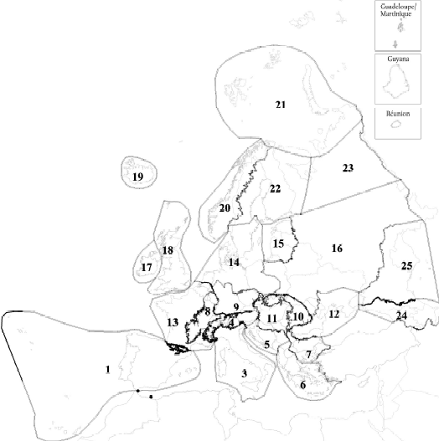

1. Iberic-Macaronesian region
2. Pyrenees
3. Italy, Corsica and Malta
4. Alps
5. Dinaric western Balkan
6. Hellenic western Balkan
7. Eastern Balkan
8. Western highlands
9. Central highlands
10. The Carpathians
11. Hungarian lowlands
12. Pontic province
13. Western plains
14. Central plains
15. Baltic province
16. Eastern plains
17. Ireland and Northern Ireland
18. Great Britain
19. Iceland
20. Borealic uplands
21. Tundra
22. Fenno-Scandian shield
23. Taiga
24. The Caucasus
25. Caspic depressi

